

**UNIVERSITY OF PETROLEUM & ENERGY STUDIES**

**SCHOOL OF COMPUTER SCIENCE**

***Department of Cybernetics***

**GRAPHICS AND ANIMATIONS TOOLS**

LAB FILE

SESSION (2020-21)

Course: BTech with specialization in Open Source & Open Standards

Submitted to: Submitted by:

Dr. Durgansh Sharma Surabhi Kumari

Associate Professor SAP: 500063663

Department of Cybernetics Roll no: R100217101

**PROJECT**

STEP 1: Open Blender.

STEP 2: Create a new file -> Delete the default cube.

STEP 3: Add a Plane to it

STEP 4: From the help of Add modifier give ocean wave in the plane and adjust it.

STEP 5: Make the Boat

STEP 6: Make the Cthulhu

STEP 7: Set the camera by fixing the focal length

STEP 8: Add a cube to it. Make it transparent

STEP 9: In Render Properties Select screen space, bloom and ambient for the smog around.

STEP 10: Give the lighting on boat and near the eyes of Cthulhu for making it visible in smog

STEP 11: Now Create material with required colors and assign it to required face.

STEP 12: Save the file and render the final model.

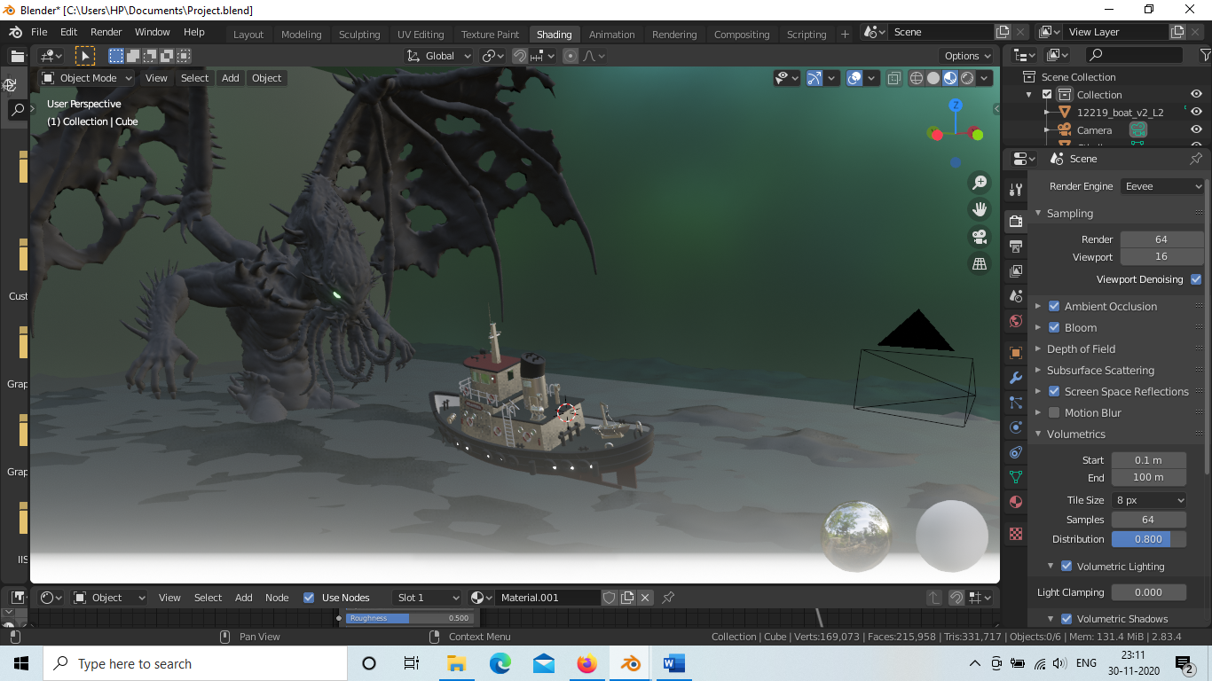

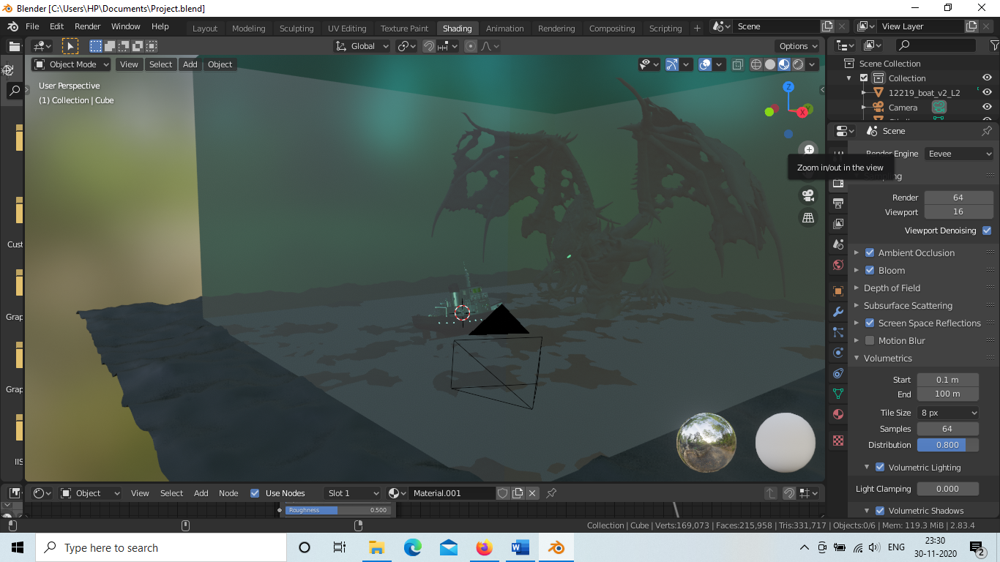

[File link](https://drive.google.com/drive/folders/1CkuvglPtNx3UX0ae9LNtI1bIV89jlWoR?usp=sharing)